**Algebra I Final Exam Review Packet Name:_________________________**

**Date:__________ Mod:___________**

**Final Exam Review Vocabulary:**

**Directions:** Match the correct vocabulary words with the definitions.

1. _____ Zeros A. a function whose graph forms a parabola

2. _____ Radical B. a polynomial of the 3rd degree

3. _____ Outlier C. the solution(s) of a quadratic function

4. _____ Discriminant D. b2 – 4ac

5. _____ Binomial E. the vertical line that divides a parabola into

two symmetrical halves

6. _____ Domain F. the square root symbol

7. _____ Standard Form G. a polynomial with two terms

8. _____ Vertex H. the sum of the exponents of the variables in

the monomial

9. _____ Quadratic I. a value that is very different from the others.

10. _____ Cubic J. the coefficient of the first term of a

polynomial in standard form

11. _____ Degree of a Monomial K. the set of the x-values of a relation

12. _____ Leading Coefficient L. the highest/lowest point on the graph of a

quadratic function

13. _____ Axis of Symmetry M. writing a polynomial from the highest

degree to the lowest degree



**Final Review Questions:**

14. Solve the following system. y = x + 1

2x + y = 10

15. Solve the following system. 2x + 4y = -20

-3x – 4y = 5

16. Simplify 

17. Simplify 

1.  B. 

C.  D.

18. Simplify 

1.  B. 

C. 3 D. -3

19. Evaluate  for x=3, and y= -1

20. Simplify 

21. Simplify 

1.  B. 

C. 125x D. 125

22. Simplify 



23. Simplify



24. Simplify 

1.  B. 

C.  D. 

25. Convert the following to exponential form:

a.  b. 

26. Convert the following to radical form:

a.  b. 

27. Find the degree of the monomial



1. 2 B. -7

C. 3 D. 1

28. Write the polynomial in standard form. Then give the leading coefficient.



Standard form: ____________________________

Leading coefficient: __________________________

29. Add



30. Subtract 

31. Distribute 

32. Multiply 

33. Multiply 

1.  B. 

C.  D. 

34. Multiply 

1. 37g + 8 B. 20g - 27g + 8

C.  D. 

35. Find the GCF of 16 and 24

A. 2 C. 4

B. 8 D. 48

36. Find the Greatest Common Factor of  and 

A.  C. 

B.  D. 

37. Factor 

38. Factor 

39. Factor 

40. Factor 

41. ***Solve*** by factoring. 3x2 – 27x = 0

42. Solve by using square roots. x2 = –25

43. Solve by using square roots. x2 = 4

A. x = 16 C. x = 2

B. x = 16 D. x = 2

44. Solve by completing the square. x2 + 16x = –15

45. Use the discriminant to find the number of solutions. 2x2 – 5x - 10

A. two solutions B. one solution

C. no real solutions D. all real solutions

46. Solve by using the quadratic formula. –5x2 + 9x + 2 = 0

A. x = 2, x = –1/5 C. x = 2, x = 0

B. x = -2, x = 1/5 D. x = -2, x = 0

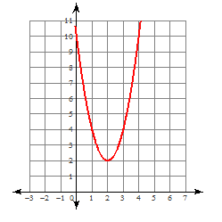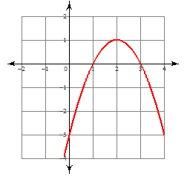47. Find the vertex and the axis of symmetry of the following parabolas.

a. b.

48. Find the axis of symmetry of the graph of y = – x2 – 6x – 7

A. x = 3 C. y = – 3

B. x = – 3 D. y = 3

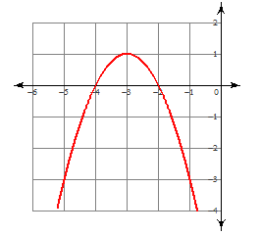49. The vertex of the parabola shows that the ________ value of the function is ___________.

A. maximum, – 3 C. minimum, – 3

B. maximum, 1 D. minimum, 1

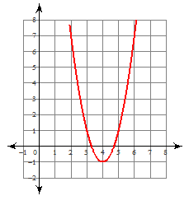50. The vertex of the parabola shows that the maximum/minimum value is ______________.

Circle: Max or Min.

51. If you graph the function x2 – 4x = 2, the y-intercept would be ________________.

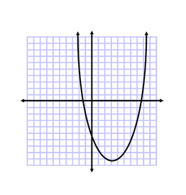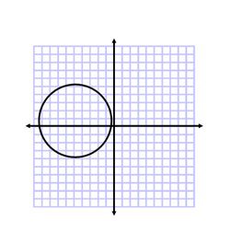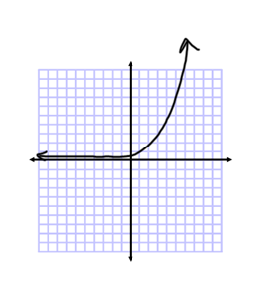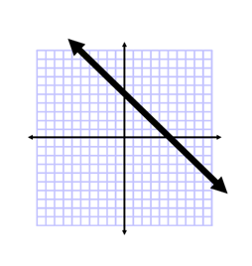52. Please label the following graphs: Linear, Quadratic, Exponential, or None.

A. B. C. D.

53. Sheamus bought a brand new car for $25,000. The value of the car depreciates at a rate of 15% per year. Find out how much his car is worth after 10 years.

**Exponential decay formula: y = a(1 – r)t**

54. Nitrogen-13 has a half-life of 10 minutes. How much would be left from a 50-gram sample in 50 minutes?

55. Flourine-18 has a half-life of 20 minutes. How much would be left from a 100-gram sample in 80 minutes?

56. Find the next three terms in this sequence: 5, 10, 20, 40, …

A. 60, 80, 100 C. 80, 160, 320

B. 20, 10, 5 D. 70, 110, 160

57. The first term of a geometric sequence is 3 and the common ratio is -2. What is the 7th term of the sequence? (Use the formula: )

58. Simplify. 

A.  C. 

B.  D. 

59. Simplify. 

60. Add.  61. Subtract. 

62. Multiply  and write the product in simplest radical form.

A.  C. 

B.  D. 

63. Multiply  and write the product in simplest radical form.

64. Multiply  and write the product in simplest radical form.

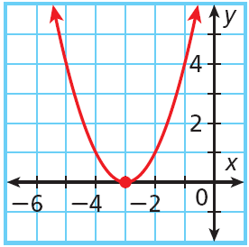65. Find the mean, median and mode of the following set of data.

Time spent on internet (minutes per day) : 75, 38, 43, 120, 65, 48, 52

**Extended Response**

66. Look for a pattern in the data set to determine which kind of model best describes the data. (Linear, Quadratic, or Exponential)

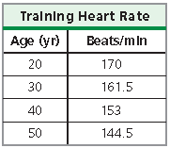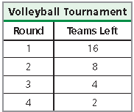A. B.

67. The population of a school of fish is increasing at a rate of 4% per year. In 2000, the population was 24,500. Write an exponential growth function to model this situation. Then find the population in the year 2020. **Exponential decay formula: y = a(1 + r)t**

68. Solve by factoring. x2 – 9x + 8 = 0

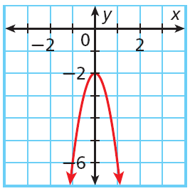69. Use the graph to find the following:

a. Axis of Symmetry ______________

b. Vertex ________________

c. Max or Min ____________

d. Max/Min value ______________



70. Use the graph to find the following:

a. Axis of Symmetry ______________

b. Vertex ________________

c. Max or Min ____________

d. Max/Min value ____________

71. Multiply. 72. Multiply.

3x(-4x3 + 15x) (2x – 1)(3x2 + 4x – 6)